## 

## **Part A-Theoretical Questions**

In this part of Linux Interview Questions, we will discuss the most common theoretical and concept based questions.

### **1. What is Linux?**

Linux is an Open-Source Operating System based on Unix. Linux was first introduced by Linus Torvalds. The main purpose of Linux was to provide free and low-cost Operating System for users who could not afford Operating Systems like Windows or iOS or Unix.

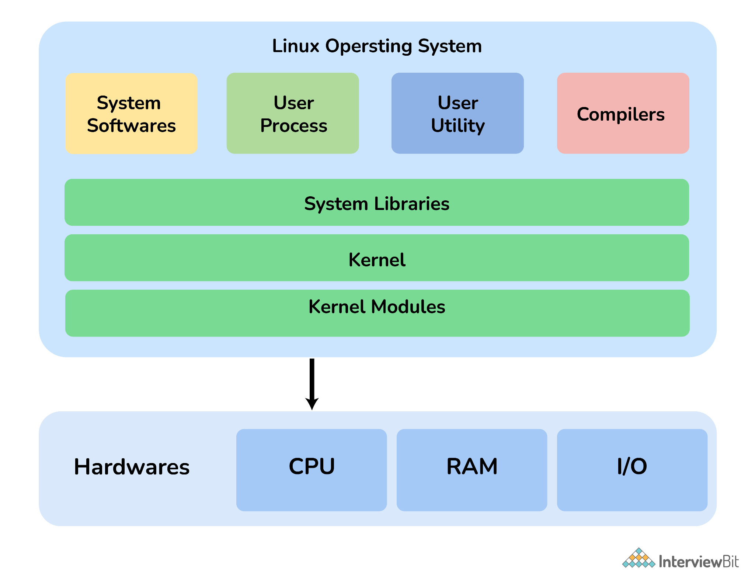

### **2. What is the difference between Linux and Unix?**

The main differences between Linux and UNIX are as follows:

| **Parameter** | **Linux** | **Unix** |
| --- | --- | --- |

| **Price** | Both free distributions and paid distributions are available. | Different levels of UNIX have a different cost structure |
| --- | --- | --- |
| **Target User** | Everyone (Home user, Developer, etc.) | Mainly Internet Server, Workstations, Mainframes. |
| **File System Support** | Ext2, Ext3, Ext4, Jfs, ReiserFS, Xfs, Btrfs, FAT, FAT32, NTFS. | jfs, gpfs, hfs, hfs+, ufs, xfs, zfs,vxfs. |
| **GUI** | KDE and Gnome | Common Desktop Environment |
| **Viruses listed** | 60-100 | 80-120 |
| **Bug Fix Speed** | Faster because Linux is Community driven | Slow |
| **Portability** | Yes | No |
| **Examples** | Ubuntu, Fedora, Red Hat, Kali Linux, Debian, Archlinux, Android, etc. | OS X, Solaris, All Linux |

Linux vs. Unix – Linux Interview Questions

### **3. What is Linux Kernel? Is it legal to edit Linux Kernel?**

Linux kernel refers to the low-level system software. It is used to manage resources and provide an interface for user interaction.

Yes, it is legal to edit Linux Kernel. Linux is released under the General Public License (General Public License). Any project released under GPL can be modified and edited by the end users.

### **4. What is LILO?**

**LILO** stands for **LI**nux **LO**ader. LILO is a Linux Boot Loader that loads Linux Operating System into the main memory to begin execution. Most of the computers come with boot loaders for certain versions of Windows or Mac OS. So, when you want to use Linux OS, you need to install a special boot loader for it. LILO is one such boot loader.

When the computer is started, BIOS conducts some initial tests and transfers control to the Master Boot Record. From here, LILO loads the Linux OS and starts it.

The advantage of using LILO is that it allows fast boot of Linux OS.

### **5. What are the basic components of Linux?**

The basic components of Linux are:

* **Kernel**: It is the core component of the Operating System that manages operations and hardware.
* **Shell**: Shell is a Linux interpreter which is used to execute commands.
* **GUI**: **GUI** stands for **Graphical User Interface** which is another way for a user to interact with the system. But unlike **CLI, GUI** consists of Images, Buttons, TextBoxes for interaction.
* **System Utilities**: These are the software functions that allows the user to manage the computer.
* **Application Programs**: Software programs or set of functions designed to accomplish a specific task.

**6. Explain the Linux Directory commands along with the description?**

**Answer:** The Linux Directory commands along with descriptions are as follows:

* **pwd:** It is a built-in command which stands for **‘print working directory’**. It displays the current working location, working path starting with/and directory of the user. Basically, it displays the full path to the directory you are currently in.
* **Is:** This command list out all the files in the directed folder.
* **cd:** This stands for ‘change directory’. This command is used to change to the directory you want to work from the present directory. We just need to type cd followed by the directory name to access that particular directory.
* **mkdir:** This command is used to create an entirely new directory.
* **rmdir:** This command is used to remove a directory from the system.

### **7. Which command is used to check the size of file or directory?**

The command used to check the size of the file or directory is “du”. Here “du” stands for disk usage that is used to check information of disk usage of files and directories on a machine. It is also used to display files and directory sizes in a recursive manner.

**Example:**

$ du -sh /var/log/*

1.8M /var/log/anaconda

384K /var/log/audit

4.0K /var/log/boot.log

0 /var/log/chrony

4.0K /var/log/cron

4.0K /var/log/maillog

64K /var/log/messages

### **8. Which command is used to count the number of characters in a file?**

### The command that is used to count the number of characters in a file in Linux is “wc”. Here “wc” stands for word count. It is used to count the number of lines, words, and characters in a text file.

### **What is the function of grep command?**

### Grep (Global regular expression print) is a command that is used for the global search for a string of characters in a specified file. The text search pattern is generally known as a regular expression. It simply makes use of pattern-based searching.

### **Syntax:** grep [options] pattern [files]

### **Example:** $ grep -c "linux" interview.txt

### The above command will usually print the total count of the word “Linux” in the file “interview.txt”.

### **9. What is the pwd command?**

“pwd” command is basically a command that is used to print the complete path of the current working directory starting from the root (/). Here, “pwd” stands for Print Working Directory. It is considered one of the most basic and most used commands in Linux. This command is usually a built-in shell command and is also available in different shells such as bash, ksh, zsh, bourne shell, etc.

### **10. Name the command that is used to check all the listening ports and services of your machine.**

# netstat -ntlp

### **11. Which command is used to check the memory status?**

The command used mostly to check memory status in Linux is “free”. Other commands that can be used are given below:

* **“cat” command:** It can be used to show or display Linux memory information. (cat/proc/meminfo)
* **“vmstat” command:** It can be used to report statistics of virtual memory.
* **“top” command:** It can be used to check the usage of memory.
* **“htop” command:** It can be used to find the memory load of each process.

### **12. Which are the Shells used in Linux?**

The most common Shells used in Linux are

* **bash: B**ourne **A**gain **Sh**ell is the default for most of the Linux distributions
* **ksh:** **K**orn **Sh**ell is a high-level programming language shell
* **csh: C Sh**ell follows C like syntax and provides spelling correction and Job Control
* **zsh: Z** **Sh**ell provides some unique features such as filename generation, startup files, login/logout watching, closing comments etc.
* **fish: F**riendly **I**nteractive **Sh**ell provides some special features like web-based configuration, auto-suggestions, fully scriptable with clean scripts

### **13. What are file permissions in Linux? Name different types of file systems in Linux.**

There are three owners in the Linux System i.e., user, group, and others. These owners have three types of permissions defined as listed below:

* **Read (r):** It allows the user to open and read the file or list the directory.
* **Write (w):** It allows the user to open and modify the file. One can also add new files to the directory.
* **Execute (x):** It allows the user to execute or run the file. One can also lookup a specific file within a directory.

### **14. What are Linux directory commands?**

There are basically five Linux directory commands that are used to work with files and directories as given below:

* **pwd:** It stands for “print working directory”. This command is generally used to display the path of the present or current working directory.   
  **Syntax:** $ pwd
* **cd:** It stands for “change directory”. This command is generally used to change the present working directory to the directory that we want to work on.   
  **Syntax:** $ cd <path to new directory>
* **Is:** It stands for “list”. This command is generally used to show the full list of content of files and directories in the present working directory.   
  **Syntax:** $ ls
* **mkdir:** It stands for “make directory”. This command generally allows users to create directories in Linux.   
  **Syntax:** $ mkdir <name (and path if required) of new directory>
* **rmdir:** It stands for “remove directory”. This command is used to remove/delete each directory that is specified on the command line.   
  **Syntax:** $ rmdir <name (and path if required) of directory>

### **15. What do you mean by unmask?**

Unmask, also known as user file-creation mask, is a Linux command that allows you to set up default permissions for new files and folders that you create. In Linux OS, unmask command is used to set default file and folder permission. It is also used by other commands in Linux like mkdir, tee, touch, etc. that create files and directories.

Syntax: unmask [-p] [-S] [mask]

Where,

[mask]: It represents the permission masks that you are applying.

[-S]: It displays the current mask as a symbolic value.

[-p]: It displays the current mask along with an unmask command thus allowing it to be copied and pasted as a future input.

### **16. Name the command used to review boot messages.**

The command that is used to review boot messages is the “dmesg” command.

### **17. What is Swap Space?**

Swap Space is the additional space used by Linux that temporarily holds concurrently running programs when the RAM does not have enough space to hold the programs. When you run a program, it resides on the RAM so that the processor can fetch data quickly. Suppose you are running more programs than the RAM can hold, then these running programs are stored in the Swap Space. The processor will now look for data in the RAM and the Swap Space.

Swap Space is used as an extension of RAM by Linux.

## **18. What are Daemons in Linux?**

**Ans.** This is another popular ***Linux interview question***. Daemons are the programs on Unix-like operating systems that run in the background instead of running under the direct control of a user. In Linux, daemons extend the functionality of the base operating system by offering functions that might not be available in the operating system.

A daemon actively listens for a service request and acts upon it at the same time. On completion of service, the daemon gets disconnected and waits for further requests.

Most have a ‘d’ at the end of the process name. Some of the service daemons for Linux systems are:

1. amd – Auto Mount Daemon
2. ftpd – FTP Server Daemon
3. httpd – Web Server Daemon
4. mysql – Database server Daemon
5. nfsd – Network File Sharing Daemon
6. sshd – Secure Shell Server Daemon

**19 Explain the term CLI?**

**Answer:** CLI stands for Command Line Interface. It is a way for humans to interact with computers and is also known as the Command-line user interface. It relies on textual request and response transaction process where the user types declarative commands to instruct the computer to perform operations.

**Advantages of CLI**

* Very flexible
* Can easily access commands
* Much faster and easier to use by expert
* It does not use much CPU processing time.

**Disadvantages of CLI**

* Learning and remembering type commands is hard.
* Have to be typed precisely.
* It can be very confusing.
* Surfing web, graphics, etc are a few tasks that are hard or impossible to do on the command line.

**20. Explain the 3 kinds of file permissions under LINUX?**

**Answer:** Every file and directory in Linux are assigned three types of owners namely ‘User’, ‘Group’, and ‘Others’. **The three kinds of permissions defined for all the three owners are:**

* **Read:** This permission allows you to open and read the file as well as list the contents of the directory.
* **Write:** This permission allows you to modify the contents of the file as well as allows adding, removing and renaming files stored in the directories.
* **Execute:** Users can access and run the file in the directory. You cannot run a file unless the execute permission is set.

### **21. What is the difference between BASH and DOS?**

There are 3 main differences between **BASH** and **DOS**:

| **Sl. no.** | **BASH** | **DOS** |
| --- | --- | --- |
| 1. | Commands are case-sensitive. | Commands are not case-sensitive. |
| 2. | **‘/’** (forward slash) is used as a directory separator.  **”** (backslash) is used as an escape character. | **‘/’** (forward slash) is used as a command argument delimiter.  **”** (backslash) is used as a directory separator. |
| 3. | Follows naming convention: 8 characters for filename postfixed with 3 characters for the extension. | No naming convention. |

Bash vs Dos – Linux Interview Questions

### **22. What command would you use to check how much memory is being used by Linux?**

You can use any of the following commands:

* free -m
* vmstat
* top
* htop

### **23. Explain file permission in Linux.**

There are 3 kinds of permission in Linux:

1. **Read**: Allows a user to open and read the file
2. **Write**: Allows a user to open and modify the file
3. **Execute**: Allows a user to run the file.

You can change the permission of a file or a directory using the **chmod**command. There are two modes of using the **chmod** command:

1. **Symbolic mode**
2. **Absolute mode**

#### **Symbolic mode**

The general syntax to change permission using Symbolic mode is as follows:

$ chmod <target>(+/-/=)<permission> <filename>

where <permissions> can be **r: read; w: write; x: execute**.

<target> can be **u : user; g: group; o: other; a: all**

'+' is used for adding permission

'-' is used for removing permission

'=' is used for setting the permission

For example, if you want to set the permission such that the user can read, write, and execute it and members of your group can read and execute it, and others may only read it.

Then the command for this will be:

$ chmod u=rwx,g=rx,o=r filename

#### **Absolute mode**

The general syntax to change permission using Absolute mode is as follows:

$ chmod <permission> filename

The Absolute mode follows octal representation. The leftmost digit is for the user, the middle digit is for the user group and the rightmost digit is for all.

Below is the table that explains the meaning of the digits that can be used and their effect.

| **0** | No permission | – – – |
| --- | --- | --- |
| **1** | Execute permission | – – x |
| **2** | Write permission | – w – |
| **3** | Execute and write permission: 1 (execute) + 2 (write) = 3 | – wx |
| **4** | Read permission | r – – |
| **5** | Read and execute permission: 4 (read) + 1 (execute) = 5 | r – x |
| **6** | Read and write permission: 4 (read) + 2 (write) = 6 | rw – |
| **7** | All permissions: 4 (read) + 2 (write) + 1 (execute) = 7 | rwx |

For example, if you want to set the permission such that the user can read, write, and execute it and members of your group can read and execute it, and others may only read it.

Then the command for this will be:

$ chmod 754 filename

### **24. Name default ports used for DNS, SMTP, FTP, SSH, DHCP and squid.**

Default ports used for various services are as follows:

| **Service** | **Port** |
| --- | --- |
| DNS | 53 |
| SMTP | 25 |
| FTP | 20 (Data transfer), 21 (Connection established) |
| SSH | 22 |
| DHCP | 67/UDP (dhcp server), 68/UDP (dhcp client) |
| squid | 3128 |

### **25. What are inode and process id?**

**inode** is the unique name given by the operating system to each file. Similarly, **process id** is the unique id given to each process.

### **26. Which are the Linux Directory Commands?**

There are 5 main Directory Commands in Linux:

**pwd**: Displays the path of the present working directory.

Syntax: $ pwd

**ls**: Lists all the files and directories in the present working directory.

Syntax: $ ls

**cd**: Used to change the present working directory.

Syntax: $ cd <path to new directory>

**mkdir**: Creates a new directory

Syntax: $ mkdir <name (and path if required) of new directory>

**rmdir**: Deletes a directory

Syntax: $ rmdir <name (and path if required) of directory>

### **27. What is Virtual Desktop?**

Virtual Desktop is a feature that allows users to use the desktop beyond the physical limits of the screen. Basically, Virtual Desktop creates a virtual screen to expand the limitation of the normal screen.

There are two ways Virtual Desktop can be implemented:

1. Switching Desktops
2. Oversized Desktops

#### **Switching Desktops**

In the case of Switching Desktops, you can create discrete virtual desktops to run programs. Here, each virtual desktop will behave as an individual desktop and the programs running on each of these desktops is accessible only to the users who are using that particular desktop.

#### **Oversized Desktops**

Oversized Desktops do not offer a discrete virtual desktop but it allows the user to pan and scroll around the desktop that is larger in size than the physical screen.

### **28. Which are the different modes of vi editor?**

There are 3 modes of **vi editor**:

1. **Regular/Command mode**: Lets you view the content
2. **Insertion/edit mode**: Lets you delete or insert content
3. **Replacement mode**: Lets you overwrite content

### **29. What are daemons?**

A daemon is a computer program that runs as a background process to provide functions that might not be available in the base Operating System. Daemons are usually used to run services in the background without directly being in control of interactive users. The purpose of Daemons is to handle periodic requests and then forward the requests to appropriate programs for execution.

### **30. What are the process states in Linux?**

The process states are as follows:

* **Ready**: The process is created and is ready to run
* **Running:** The process is being executed
* **Blocked or wait:** Process is waiting for input from the user
* **Terminated or Completed:** Process completed execution, or was terminated by the Operating System
* **Zombie:** Process terminated, but the information still exists in the process table.

### **31. Explain grep command.**

Grep stands for **Global Regular Expression Print.** The grep command is used to search for a text in a file by pattern matching based on regular expression.

**Syntax**: grep [options] pattern [files]

**Example**:

$ grep -c "linux" interview.txt

This command will print the count of the word “**linux**” in the “**interview.txt**” file.

### **32. Explain Process Management System Calls in Linux**

The System Calls to manage the process are:

* **fork (**) : Used to create a new process
* **exec()** : Execute a new program
* **wait()** : Wait until the process finishes execution
* **exit()** : Exit from the process

And the System Calls used to get Process ID are:

* **getpid()**:- get the unique process id of the process
* **getppid()**:- get the parent process unique id

### **33. Explain the ‘ls’ command in Linux**

The **ls** command is used to list the files in a specified directory. The general syntax is:

$ ls <options> <directory>

For example, if you want to list all the files in the **Example** directory, then the command will be as follows:

$ ls Example/

There are different options that can be used with the ls command. These options give additional information about the file/ folder. For example:

| -l | lists long format (shows the permissions of the file) |
| --- | --- |
| -a | lists all files including hidden files |
| -i | lists files with their inode number |
| -s | lists files with their size |
| -S | lists files with their size and sorts the list by file size |
| -t | sorts the listed files by time and date |

### **34. Explain the redirection operator.**

The redirection operator is used to redirect the output of a particular command as an input to another command or file.

There are two ways of using this:

**‘>’** overwrites the existing content of the file or creates a new file.

**‘>>’** appends the new content to the end of the file or creates a new file.

Suppose the content of the file is as follows:

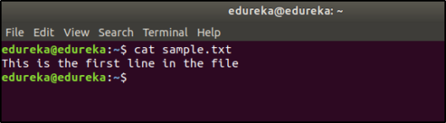

Now when you use the **‘>’** redirection operator, the contents of the file are overwritten.

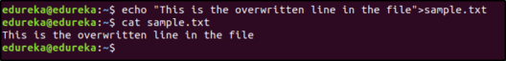

and when you use ‘>>’, the contents are appended:

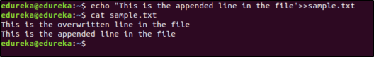

### **35. Enlist some Linux networking and troubleshooting commands?**

### Answer: Every computer is connected to the network internally or externally for the purpose of exchanging information. Network troubleshooting and configuration are essential parts of network administration. The networking commands enable you to quickly troubleshoot connection issues with another system, check the response of another host, etc.

A network administrator maintains a system network that includes network configuration and troubleshooting. Mentioned below are few commands along with their description:

Mentioned below are few commands along with their description

Hostname: To view the hostname (domain and IP address) of the machine and to set the hostname.

Ping: To check if the remote server is reachable or not.

ifconfig: To display and manipulate route and network interfaces. It displays network configuration. ‘ip’ is the replacement of ifconfig command.

netstat: It displays network connections, routing tables, interface statistics. ‘ss’ is the replacement of netstat command which is used to get more information.

Traceroute: It is a network troubleshooting utility that is used to find the number of hops required for a particular packet to reach the destination.

Tracepath: It is the same as traceroute with a difference that it does not require root privileges.

Dig: This command is used to query the DNS name servers for any task related to the DNS lookup.

nslookup: To find DNS related query.

Route: It shows the details of the route table and manipulates the IP routing table.

mtr: This command combines ping and track path into a single command.

Ifplugstatus: This command tells us whether the network cable is plugged in or not.

### **36. Why is the tar command used?**

The **tar** command is used to extract or create an archived file.

Suppose you want to extract all the files from the archive named sample.tar.gz, then the command will be:

$ tar -xvzf sample.tar.gz

Suppose you want to create an archive of all the files stored in the path /home/linux/, then the command will be:

$ tar -cvzf filename.tar.gz

where **c: create archive, x: extract, v: verbose, f: file**

### **37. What is a Microprocessor?**

A Microprocessor is a device that executes instructions. It is a single-chip device that fetches the instruction from the memory, decodes it and executes it. A Microprocessor can carry out 3 basic functions:

1. Mathematical operations like addition, subtraction, multiplication, and division
2. Move data from one memory location to another
3. Make decisions based on conditions and jump to new different instructions based on the decision.

### **38. Explain Regular Expressions and Grep**

Regular Expressions are used to search for data having a particular pattern. Some of the commands used with Regular Patterns are: **tr, sed, vi** and **grep.**

Some of the common symbols used in Regular Expressions are:

| . | Match any character |
| --- | --- |
| ^ | Match the beginning of the String |
| $ | Match the end of the String |
| * | Match zero or more characters |
|  | Represents special characters |
| ? | Match exactly one character |

Suppose the content of a file is as follows:

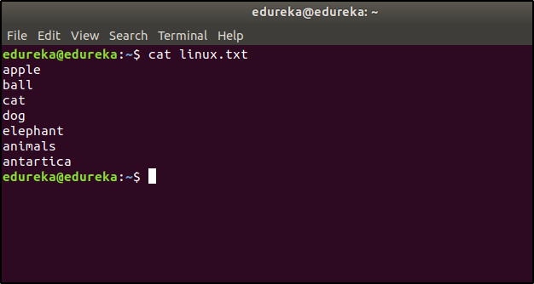

If you want to list the entries that start with the character ‘a’, then the command would be:

$ cat linux.txt | grep ^a

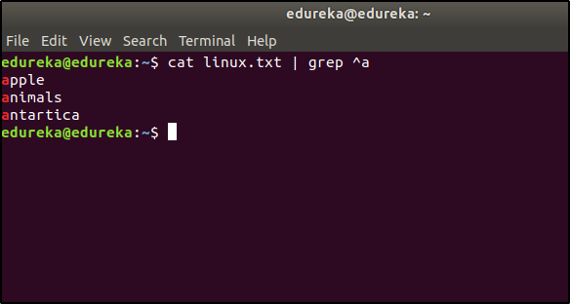

If you want to list the entries that start has the character ‘n’, then the command would be:

$ cat linux.txt | grep n

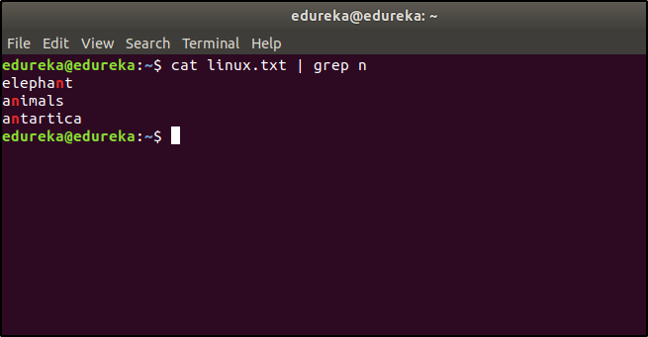

### **39. What is known about grep commands?**

### Answer: Grep stands for ‘global regular expression print’. This command is used for matching a regular expression against text in a file. This command performs pattern-based searching and only the matching lines are displayed as output. It makes use of options and parameters that are specified along with the command line.

### For example: Suppose we need to locate the phrase “our orders” in an HTML file named “order-listing.html”.

### Then the command will be as follows:

### $ grep “our orders” order-listing.html

### The grep command outputs the entire matching line to the terminal.

### **40. What is the minimum number of disk partitions required to install Linux?**

The minimum number of partitions required is 2.

One partition is used as the local file system where all the files are stored. This includes files of the OS, files of applications and services, and files of the user. And the other partition is used as Swap Space which acts as an extended memory for RAM.

### **Part B – Scenario Based Questions**

Interviewers will ask scenario based questions along with theoretical questions to check how much hands-on knowledge you have. In this part of Linux Interview Questions, we will discuss such questions.

### **1. How to copy a file in Linux?**

You can use the **cp** command to copy a file in Linux. The general syntax is:

$ cp <source> <destination>

Suppose you want to copy a file named **questions.txt** from the directory **/new/linux** to **/linux/interview,** then the command will be:

$ cp questions.txt /new/linux /linux/interview

### **2. How to terminate a running process in Linux?**

Every process has a unique **process id.** To terminate the process, we first need to find the process id. The ps command will list all the running processes along with the process id. And then we use the kill command to terminate the process.

The command for listing down all the processes:

### **Operating Systems Training**

$ ps

Suppose the process id of the process you want to terminate is 3849, then you will have to terminate it like this:

$ kill 3849

### **3. How to rename a file in Linux?**

There is no specific command to rename a file in Linux. But you use the copy or move command to rename the file.

**Using the Move command**

$ mv <oldname> <newname>

**Using the Copy command**

$ cp <oldname> <newname>

And then delete the old file.

$ rm <oldname>

### **4. How to write the output of a command to a file?**

You can use the **redirection** operator (>) to do this.

Syntax: $ (command) > (filename)

### **5. How to see the list of mounted devices on Linux?**

By running the following command:

$ mount -l

### **6. How to find where a file is stored in Linux?**

You can use the **locate** command to find the path to the file.

Suppose you want to find the locations of a file name sample.txt, then your command would be:

$ locate sample.txt

### **7. How to find the difference in two configuration files?**

You can use the **diff** command for this:

$ diff abc.conf xyz.conf

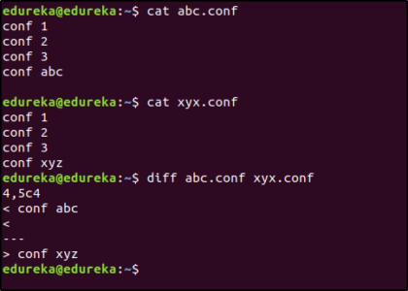

### **8. Write a bash script to delete all the files in the current directory that contains the word “linux”.**

for i in *linux*; do rm $i; done

### **9. How would you create a text file without opening it?**

The **touch** command can be used to create a text file without opening it. The **touch command** will create an empty file. The syntax is as follows:

$ touch <filename>

Suppose you want to create a file named sample.txt, then the command would be:

$ touch sample.txt

### **10. How would you delete a directory in Linux?**

There are two commands that can be used to delete a directory in Linux.

* **rmdir**

$ rmdir <directory name>

* **rm -rf**

$ rm -rf <directory name>

**Note**: The command **rm -rf** should be used carefully because it will delete all the data without any warnings.

### **11. How would you schedule a task in Linux?**

There are two commands to schedule tasks in Linux: **cron** and **at.**

The **cron** command is used to repeatedly schedule a task at a specific time. The tasks are stored in a **cron** file and then executed using the **cron** command. The **cron** command reads the string from this file and schedules the task. The syntax for the string to enter in the **cron file** is as follows:

<minute> <hour> <day> <month> <weekday> <command>

Suppose you want to run a command at 4 pm every Sunday, then the string would be:

0 16 * * 0 <command>

The **at** command is used to schedule a task only once at the specified time.

Suppose you want to shut down the system at 6 pm today, then the command for this would be:

$ echo "shutdown now" | at -m 18:00

### **12. Suppose you try to delete a file using the rm command and the deletion fails. What could be the possible reason?**

* The path specified to the file or the file name mentioned might be wrong
* The user trying to delete the file might not have permissions to delete the file.

### **13. How do you look at the contents of a file named sample.z?**

The **.z** extension means that the file has been compressed. To look at the contents of the compressed file, you can use the **zcat** command. Example:

$ zcat sample.z

### **14. How to copy files to a Floppy Disk safely?**

Follow these steps to copy files to a Floppy Disk safely:

1. Mount the floppy disk
2. Copy the files
3. Unmount the floppy disk

If you don’t unmount the floppy disk, then the data might become corrupted.

### **15. How to identify which shell you are using?**

Open the terminal and run:

$ echo $SHELL

This will print the name of the Shell being used.

### **16. How can you login to another system in your network from your system?**

**SSH** can be used for this. The Syntax is as follows:

ssh <username>@<ip address>

Suppose you want to login into a system with IP address 192.168.5.5 as a user “mike”, then the command would be:

$ ssh mike@192.168.5.5

### **17. How would you open a file in read-only mode using the vim editor?**

$ vim -R <filename>

### **18. How would you search for a specific Employee ID in a file using the vim editor?**

$ vim +/<employee id to be searched> <filename>

### **19. How to jump to a particular line in a file using vim editor?**

$ vim +<line number> <filename>

### **20. How do you sort the entries in a text file in ascending order?**

This can be done using the **sort** command.

$ sort sample.txt

### **21. What is the export command used for?**

The **export** command is used to set and reload the environment variables. For example, if you want to set the Java path, then the command would be:

$ export JAVA_HOME = /home/user/Java/bin

### **22. How do you check if a particular service is running?**

$ service <servicename> status

### **23. How do you check the status of all the services?**

$ service --status-all

### **24. How do you start and stop a service?**

To start:

$ service <servicename> start

To stop:

$ service <servicename> start

### **25. Explain the free command.**

This command is used to display the free, used, swap memory available in the system.

Typical free command output. The output is displayed in bytes.

$ free

